- Logging In
  - Go to https://sso.ipsd.org
    - Be sure to include https
    - Or follow the Student Single Sign-On link on your school’s website
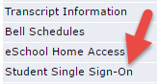

  - Using your District credentials, login to the SSO
    - Username: computer login (ex. mickeymou1234)
    - Password: current District password

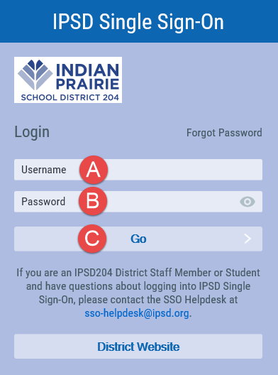

** If you need any assistance with the SSO, please contact a teacher or staff member at your building. **

